Fire Safety Plan

for:

(Business Address)

(Business Name)

Building Address must be visible from street.

The Fire-fighter’s Key Box (CHUBB) location is: .

The fire safety plan approved location is: Posted in the main reception area.

Fire Safety Plan Prepared By:

__________________________________
Owner’s Authorizing Signature

Approved By: __________________________________
Chief Fire Official

Date Approved: _________________________________

The reproduction or use of this fire safety plan for non-commercial purposes is permitted and encouraged. Permission to reproduce the plan for commercial purposes must be obtained from the Brockville Fire Department.
Table of Contents

TOPIC PAGE

Part 1 Introduction

Part 2 Human Resources Audit

Part 3 Building Resources Audit

Part 4 Building Schematics, including Site Plan

Part 5 Persons Requiring Assistance

----------------------------------------- Firefighter’s Plan --------------------------------------------------

Part 6 Emergency Procedures — Occupants

Part 7 Emergency Procedures — Supervisors

Part 8 Responsibilities of the Owner/Occupant

Part 9 Fire Hazards – Residential
Part 9 Fire Hazards — Commercial

Part 10 Fire Extinguishment/Control/Confinement

Part 11 Alternative Measures

Part 12 Fire Drills

Part 13 Maintenance Requirements of Building Fire
And Life Safety Systems

Part 14 Fire Safety Plan Review Sign-off Record

Part 1
Introduction

A Fire Safety Plan (FSP) shall be prepared, approved and implemented in buildings regulated by Article 2.8.1.1. of the Ontario Fire Code (see submission procedures below).

Section 2.8 of the Ontario Fire Code, requires the implementation of a FIRE SAFETY PLAN for this building/occupancy. In a hotel establishment, one copy of the approved fire safety plan shall be posted in the main reception area. Therefore, this will be the approved location; other copies may be kept elsewhere.

The implementation of the Fire Safety Plan helps to ensure effective utilization of life safety features in a building to protect people from fire. The required Fire Safety Plan shall be designed to suit the resources of each individual building or complex of buildings.

It is the responsibility of the owner to ensure that the information contained within the Fire Safety Plan is accurate and complete. As required by the Fire Code, the Fire Safety Plan must be reviewed as often as necessary, but at intervals not greater than 12 months to ensure that it takes account of changes in the use and other characteristics of the building (Ontario Fire Code 2.8.2.1.(4) of Division B). As defined in the Ontario Fire Code, “Owner” means any person, firm or corporation having control over any portion of the building or property under consideration and includes the persons in the building or property.

The Fire Protection and Prevention Act, 1997, Part VII, Section 28, states that in the case of an offence for contravention of the fire code, a corporation is liable to a fine of not more than $100,000 and an individual person, a director or officer of a corporation is liable to a fine of not more than $50,000 or imprisonment for a term of not more than one year or both.

This official document is to be kept readily available at all times for use by staff and fire officials in the event of an emergency.

The Fire safety Plan is also used to provide training to the building’s staff. Employees in a hotel establishment shall be instructed on the fire emergency procedures as described in the fire safety plan before they are given any responsibility for fire safety and the use of fire fighting equipment, including portable fire extinguishers and, where applicable, standpipe and hose systems.

In hotel establishments, there shall be sufficient supervisory staff available to carry out the duties as required in the fire safety plan, and in buildings greater than three storeys in building height or having a total area greater than 4000 m2, supervisory staff shall be on duty whenever the building is occupied.

SUBMISSION PROCEDURES

At least two (2) copies of the Fire Safety Plan (8 ½ X 11 format) must be submitted to the Chief Fire Official. Upon approval, one copy will be returned to the author and one copy will be retained by the Fire Department. A copy of the plan returned to the author must be placed on site in the approved location as noted on the cover page.

Note: Whenever you see the word “approved”, it means “Approved by the Chief Fire Official” and in this case, by the Fire Department official who approved and signed this plan.

The Chief Fire Official is to be notified regarding any subsequent changes in the approved Fire Safety Plan.
Part 2
Audit of Human Resources

Business/Building Name:

Municipal Address:

Business Phone Number: Business Fax Number:
---------------------------------------------------------------------------------------------------------------------

Building Owner:
Mailing Address:

Phone Number(s): Work: Fax No:
Cell:
Home: Email:
---------------------------------------------------------------------------------------------------------------------
Business Owner: If Req'd or N/A
Mailing Address:

Phone Number(s): Work: Fax No:
Cell:
Home: Email:
---------------------------------------------------------------------------------------------------------------------
Property Management Company: No Yes

Company Name:
Address:

Phone Number(s): Work: Fax No:

Contact Person: Cell:
Home: Email:
---------------------------------------------------------------------------------------------------------------------

After Hour Emergency Contacts (24 hour telephone numbers)
(Contacts normally called in order of nearness to the property for quickest response. Home address and phone number required to fulfil responsibilities.)

Name: Home #: Cell #:
Position: Pager #: Other:
Address:
---------------------------------------------------------------------------------------------------------------------
Name: Home #: Cell #:
Position: Pager #: Other:
Address:
---------------------------------------------------------------------------------------------------------------------
Name: Home #: Cell #:
Position: Pager #: Other:
Address:
---------------------------------------------------------------------------------------------------------------------
Name: Home #: Cell #:
Position: Pager #: Other:
Address:
---------------------------------------------------------------------------------------------------------------------

Other Key Contacts

Fire Alarm Monitoring Company: (Name) Phone: Pager/Cell:

Fire Alarm Company: Phone: Pager/Cell:

Sprinkler Company: Phone: Pager/Cell:

Fire Extinguisher Company: Phone: Pager/Cell:

Security Company: Phone: Pager/Cell:

Electrical Contractor: Phone: Pager/Cell:

Plumbing Contractor: Phone: Pager/Cell:

Other: Phone: Pager/Cell:

---------------------------------------------------------------------------------------------------------------------

Part 3
Audit of Building Resources Checklist

Occupancy Type: (Residential, Assembly, Mixed, etc) Occupant Load: (if applicable)
Building Height in Storeys: Storey(s) Below Grade:
Year Built: Additions/Renovations:
Building Construction: (combustible, non-combustible, etc.)

Section 9.9 Retrofit for Hotels applies to this building: No Yes
NOTE: Section 9.9 does not apply to buildings or parts thereof that satisfy the requirements of the Building Code as it read on or after July 1, 1993. (B 9.1.2.2.(2))

Fire Department Access

Brief Description of Fire Dept. Access to Building: Explain how firefighters gain access to property & building (from street) and location of alarm/annunciator panel (type over this wording).

Fire Access Routes and access panels or windows provided to facilitate access for firefighting operations shall not be obstructed by vehicles, gates, fences, building materials, vegetation, signs or any other form of obstruction.

Designated Fire Route: No Yes

Nearest Municipal Hydrant Location:

Private Hydrants: No Yes (Location(s)):

Fire Department Connection: No Yes (Location(s)):

NOTE: Fire Dept. connections shall be equipped with plugs or caps that are secured wrench-tight.

Fire Pump: No Yes (Location(s):

Fire Pump Description:

Utilities and Shut-offs

Heating System: Natural Gas Electric Fuel Oil Other:

Main Gas Shut-off: No Yes Location(s):

Main Electrical Shut-off Location:

Main Domestic Water Shut-off Location:

Other Shut-off: Location:

Fire Protection Systems

NOTE: In the event that the municipal fire department finds it necessary to reset, restore or perform emergency measures on any fire protection system, or to contact a contractor for repairs to any fire protection system, the municipality shall incur no liability or costs by such action.

Fire Alarm System: No Yes

The following information is required by Article B 6.3.2.2.(3) of Fire Code & Clause 3.6 of CAN/ULC- 536 Standard.

Type: - stage alarm (single or two) or Interconnected Smoke Alarm System

NOTE: Interconnected smoke alarms installed as a fire alarm system shall be tested and maintained in operating condition in conformance with CAN/ULC-S552, “Standard for the Maintenance and Testing of Smoke Alarms”, and as required by the Fire Code.

Where Fire Alarm Signal Monitoring is NOT provided, signage must be posted over each pull station with wording that the Fire Department must be notified in the event of an emergency and the Emergency Telephone Number (9-1-1) .

Alarm Signal Monitoring: No Yes, by

Remote Monitoring Station Direct to Fire Department Proprietary Signalling System

Where the Building Code or this Code require a fire alarm system to be monitored to transmit a signal to the fire department, the building owner shall ensure the continuation of the monitoring.

Fire Alarm Manufacturer Name/Make:

Model:

Main Panel Location:

Annunciator Panel Location:

Description of Degraded Mode Capability: (If applicable or else delete) A network operating feature where, under conditions of a communications link failure, each network segment remaining in communication shall maintain continual function as a group.

Emergency Power Supply for Fire Alarm: (i.e. Batterie(s) located in Fire Alarm Control Panel or in one central location or supplied by emergency generator or combination of both. Describe battery type, charging procedure and maintenance (Type over this wording).

NOTE: The duration of supervisory power for the fire alarm is a minimum of 24 hours followed by a full alarm operation for minutes (5, 30, 60, or 120 minutes).

Fire Alarm Description: Is system zoned, non-coded, single or 2-stage. If a 2-stage system - explain alert signal & alarm signal sequence here (i.e. second stage on fire floor and floor above and below, and ¹st stage alert signal on all other floors or areas). If a single stage system, give brief description of system (Type over this wording)

Fire Alarm Devices and Locations:

Manual Pull Stations: the main reception area, and near every exit. on each floor (Type over examples & delete unnecessary wording)

Smoke Detectors: in all stairways and corridors on all storeys

Heat Detectors: at top of elevator shafts, in service and storage rooms, laundry room & parking garage

Duct-type Smoke Detectors: in air handling systems

Ancillary Systems: kitchen extinguishing system, (also list others)

Sounding Devices: Bells/Horns/Speakers (choose type) throughout building & in each dwelling unit

Visual Signal Devices: in all public areas

Emergency Telephones: at exits

Sprinkler Flow and Valve Supervisory Switches: on a floor-by-floor basis

Alarm Activation: How does alarm activate? (Type over)

Acknowledging Trouble Alarm: How is this done? (Type over)

Note: A trouble signal sounding device and, where the trouble signal sounding device has a silencing switch, a trouble light shall be installed in the main reception area, or a continuously supervised area..

Acknowledging Alarm Signal: How is this done? (Type over)

Alarm Silencing: Provide complete procedure to silence alarm (Type over)

Alarm Re-setting: Provide complete procedure to reset fire alarm system (Type over)

NOTE: Fire alarm system shall not be reset until permission given by on-scene fire department personnel following an emergency response.

Voice Communication Equipment: Explain system and its operation (Type over)

Note: A voice communication system shall be provided in each building where the vertical distance between the floor of the top storey and grade exceeds 36 m.

Emergency Telephone Equipment: Explain system and its operation (Type over)

Ancillary Devices: Sprinkler flow switches No Yes
Air supply fan shutdown No Yes
(Recirculating air handling systems that serve more than one guest suite or storey shall be arranged to shut down upon actuation of the fire alarm system, except where continued operation of the air handling system serves as part of a smoke control system.)

Magnetic door hold-open devices No Yes
(Hold-opens must release on activation of fire alarm or power disruption)
Electromagnetic Locking Devices No Yes
(Mag-locks must release on activation of fire alarm or power disruption)

Manual release switch location for mag-locks: N/A

Note: Doors equipped with magnetic locking devices must be provided with proper signage.

Location(s) throughout building: List all locations of mag-locks here (Type over)

Smoke Control Measures: No Yes

Automatically Shuts-Off With Activation of Fire Alarm No Yes

Note: Buildings containing a hotel where the vertical distance between the floor of the top storey and grade exceeds 18 m shall have smoke control measures in conformance with Article 9.9.2.15of Div. B of the Fire Code.

Sprinkler System: No Yes Type: Wet Dry Other:

Coverage Area:

Connected to the Fire Alarm System: No Yes

Location of Sprinkler Room/Shut Off Valves:

Fire Department Connection: No Yes Location(s):

NOTE: (i) The Chief Fire Official shall be notified when any alterations, additions or repairs are to be made involving the interruption to a sprinkler system.

(ii) In a hotel, sprinkler control valves and sprinkler water supplies shall not be shut down, disconnected or otherwise impaired (a) for 24 hours or less without notifying the Chief Fire Official in accordance with a schedule identified in the approved fire safety plan, or (b) for more than 24 hours without notifying the Chief Fire Official.

Standpipe System: No Yes Locations:

Location of Shutoff/Isolation Valves:

NOTE: (i) Each Hose Connection in a standpipe system shall have a legible sign reading;
“FIRE HOSE FOR USE BY TRAINED PERSONS ONLY”
(ii) Employees in a hotel establishment shall be instructed on the use of standpipe and hose systems where applicable.
(iii) Standpipe Hose Stations shall be conspicuously identified and unobstructed, and shall be used for fire protection only.

Fire Department Connection: No Yes Location(s):

NOTE: In a hotel, a standpipe and hose system shall not be shut down, disconnected or otherwise impaired without notifying the Chief Fire Official in accordance with a schedule identified in the approved fire safety plan. A standpipe system shall be served by at least one fire department connection located on the outside of the building adjacent to a street, readily accessible to the fire department.

Portable Fire Extinguishers: Types:

Locations: (Also refer to schematic drawings in Part 4)

NOTE: Employees in a hotel establishment shall be instructed on the use of firefighting equipment, including portable fire extinguishers.

Fixed Extinguishing System for Commercial Cooking Equipment No Yes

Type: (i.e. Wet Chemical, Dry Chemical, CO²)

Connected to Fire Alarm System: No Yes

Fuel Source: Natural Gas Electric Other:

Fuel Shut Off for Appliance(s): Location(s):

40BC Extinguisher or Class K Type: Location:

NOTE: Commercial cooking equipment exhaust and fire protection systems shall be maintained in conformance with NFPA 96, “Standard for Ventilation Control and Fire Protection of Commercial Cooking Operations”.

Manual Operation of System: The manual operation instructions are posted (usually on the faceplate of the manual pull station or on wall adjacent to the pull station - write in proper location & type over)

System Operating Instructions: instructions for operation of the system are to be written here or refer to an attached manual. An instruction manual can be added as an appendix to the plan (type over text)

Other Extinguishing Systems: N/A

Type:  (i.e.pre-action,sprinkler,dry chemical) | Area/Location Protecting

Emergency Lighting: No Yes

Location(s):

Upon failure of regular power source, Emergency Lighting for this building is required to have an alternative power supply that provides lighting for 30 minutes. 1 hour. 2 hours.
Emergency Power: No Yes Type: Battery or Generator
(for emergency lights, etc.)

Generator: N/A

Fuel Type: Diesel Natural Gas Gasoline Other:

Fuel Supply Location:

Transfer Switch Location:

Equipment Powered by Generator:

Extra Hazardous Area:

Is there hazardous materials on site? No Yes

If YES, please list the material, quantity and location (also mark locations on schematics):

Is there Flammable Liquids (i.e. gasoline) or Combustible Liquids stored on site? No Yes
(Storage of these liquids must be stored in compliance with Part 4 of Division B of the Ontario Fire Code)

If YES, please list the material, quantity and location (also mark locations on schematics):

Exits: (location of)

(Briefly describe exit locations - type over this section) Refer to schematics for location of exits.

Elevators: No Yes

NOTE: At least one elevator shall be provided for use by firefighters where the vertical distance between the floor of the top storey and grade exceeds 18 m.

Firefighter (FF) Elevator Firefighter Service
(RED HELMET designation) (YELLOW HELMET designation)

The required firefighters' elevator symbol shall be maintained in identifiable condition.

Automatic Recall by Fire Alarm: No Yes Manual Recall: No Yes

Manual Recall Switch(es): No Yes Location:

Homing Floor(s) for FF Elevator Recall:

Total Number of Elevators in building: Total Number of FF Elevators:

FF Elevator Location:

Floors Served by FF Elevator:

Location of recall/operating keys:

Operating Instructions:

Mechanical Air-Conditioning and Ventilating Systems

Disconnect switches: No Yes Location(s):

NOTE: Except for self-contained systems within guest suites and dwelling units, disconnect switches for mechanical air-conditioning and ventilating systems shall be operated annually to establish that the system can be shut down.

Part 3 Additional Information

This area is to provide other information on your building not already addressed, and associated with other Fire Code references such as Division B 2.2.3.5.(2)(b), 2.9.3.2., 3.5.3.3.(2) etc. Check the Fire Code to ensure all required information is included in this plan.

Part 4
Please take time to review this page. If all icons required for your building schematics have been transferred to a legend on each drawing, this page can be deleted. Other symbols are acceptable if consistently used throughout schematics.

LEGEND FOR BUILDING / UNIT FIRE EMERGENCY SYSTEM
 | Pull Pin For Kitchen Fire Suppression System
 | Entrance / Exit
 | Hydrant
 | Siamese Fire Department Connection
 | Free Standing Siamese Fire Department Connection
 | Valves (General)  Identify The Type Of Valve (Ie. Shut Off Valve For Natural Gas, Sprinklers, Etc.)
 | Fire Alarm Control Panel
 | Fire Alarm Annunciator
 | Emergency Light, Battery-Powered
 | Illuminated Exit Sign, Single Face
 | Combined Battery-Powered Emergency Light & Illuminated Exit Sign
 | Pull Station
 | Heat Detector
 | Smoke Detector
 | Fire Extinguisher - BC Type
 | Fire Extinguisher - ABC Type
 | Fire Extinguisher - Water
 | Hose Cabinet
 | Sprinkler Riser, indicate whether Wet or Dry System

Site Plan
Please attach Site Plan to email or send with printed copies.
(Include Legend on each page)

Site Plan will include location of property on city street showing street name (cross streets where applicable), and fire access route from street to building’s principal entrance (firefighters access point). The fire department connection will also be indicated, as well as any exterior utility shutoffs such as gas lines, and any outbuildings on the property. A legend showing symbols will be included on site plan drawing as well as a direction “North” symbol.

This page can be deleted after the Site Plan is inserted into this document in this location.

See Attached Example on Following Page

Floor Plan(s)
Please attach Floor Plan to email or send via postal mail.
(Include Legend)

A floor plan is required for each floor storey of the building. If the building has a different layout for a basement storey and the first storey, but the 2nd to 5th story are identical, you must provide a floor plan for the basement, the 1st storey and one plan for the upper identical floors marked “Floor Plan 2 - 5 Floors”. Apartment numbers, for example, on these identical floors can be put in as _06, which indicates 206, 306, 406, etc. If the building has roof access and machinery rooms on the roof, include this plan as well. A legend showing symbols will be included on site plan drawing as well as a direction “North” symbol.

Symbols on floor plan will include locations of exits, emergency lighting, fire alarm pull stations, fire extinguisher locations, hose cabinets, etc.

Drawings do not need to be to scale but must be drawn to a reasonable facsimile. Drawings must be neat and legible or will not be accepted. Agencies are available to assist an owner in providing detailed floor plans of their buildings.

This page can be deleted after each Floor Plan is inserted into this document in this location.

See Attached Examples on Following Pages

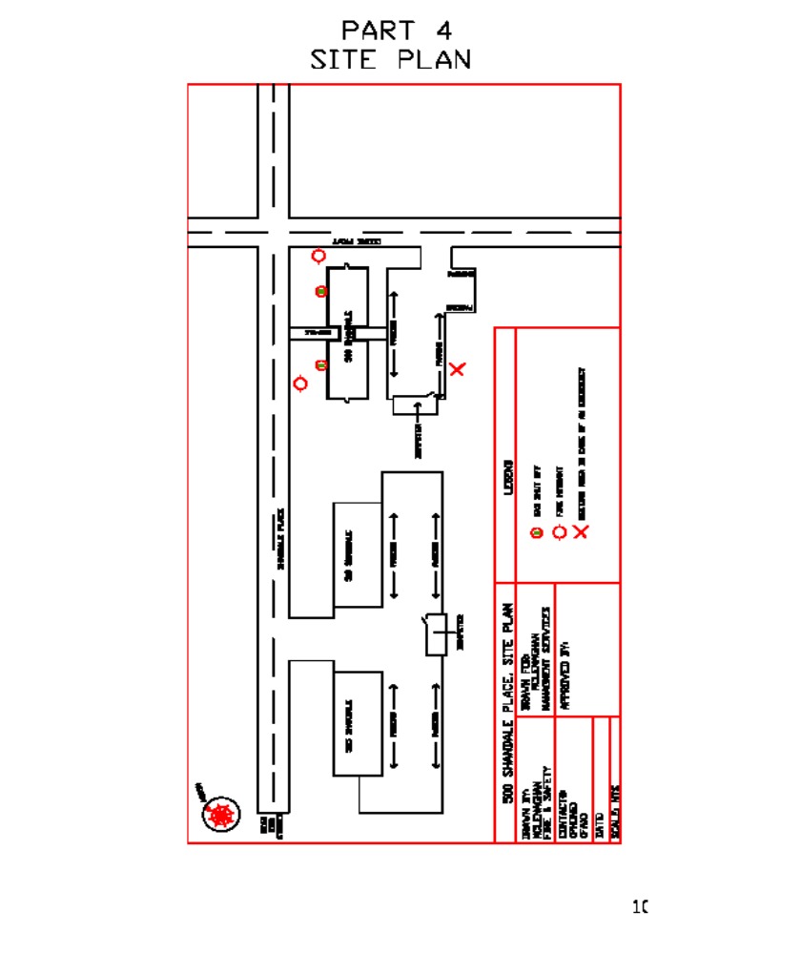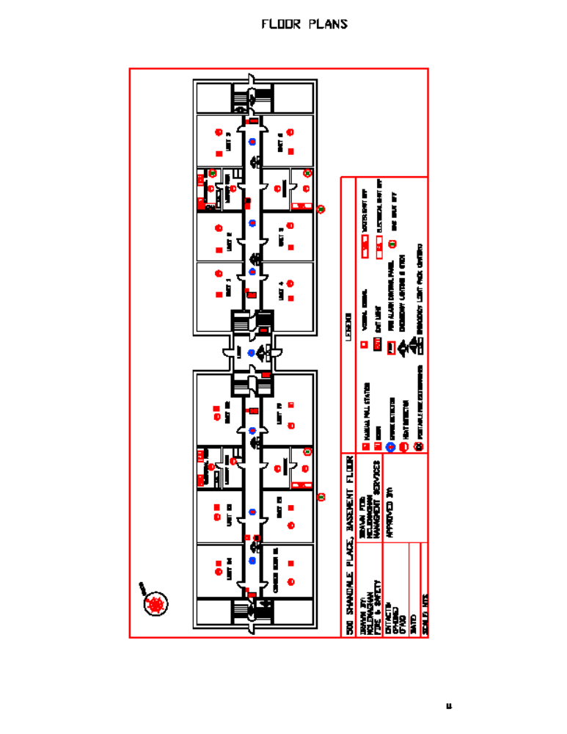
EXAMPLE SITE PLAN

EXAMPLE FLOOR PLAN
Basement Storey

EXAMPLE FLOOR PLAN
1st Storey
EXAMPLE FLOOR PLAN
First Storey
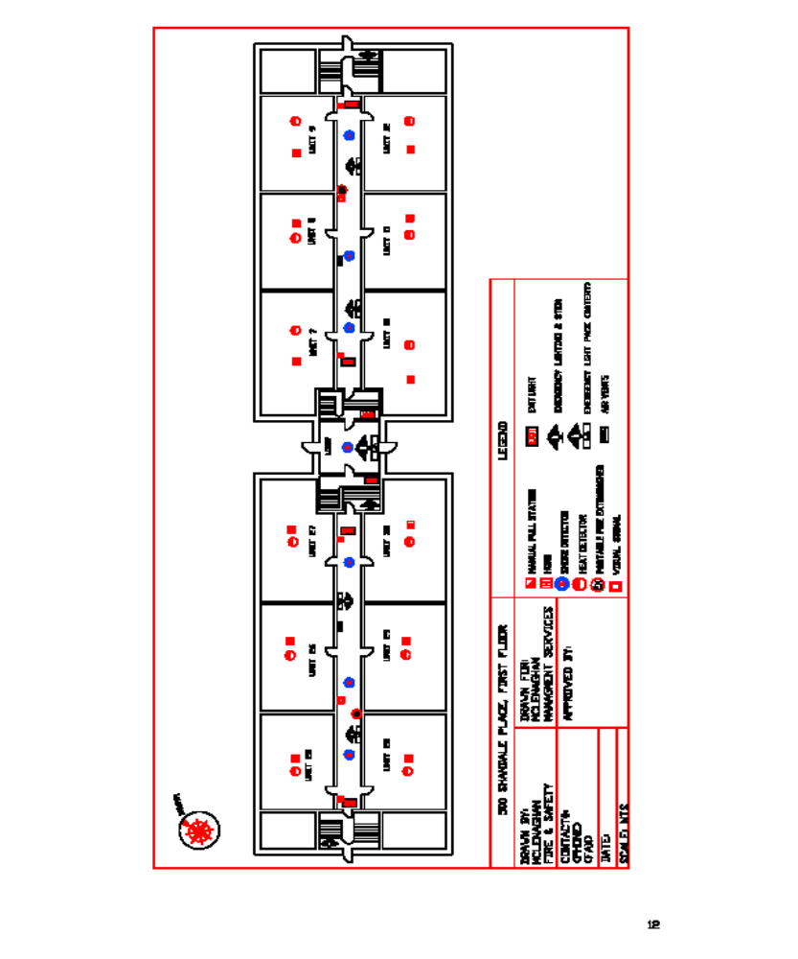Part 5

PERSONS REQUIRING ASSISTANCE

Persons that are handicapped and/or require assistance in the event of an evacuation of the building are requested to advise management in order that they may render assistance. The list of persons requiring assistance is identified by a printed report off of the hotel system, each person/room is marked that requires special assistance.

IN THE EVENT OF AN EMERGENCY, STAFF MEMBERTS ARE TO COMPLETE THE FOLLOWING:

- PROVIDE ASSISTANCE TO MAINTAIN A CALM AND ORDERLY EVACUATION IN SUCH A WAY AS TO NOT INVOKE PANIC
- ASSIST PATRONS/OCCUPANTS TO EXIT THE BUILDING. PATRONS ARE TO BE DIRECTED TO EVACUATE VIA THE NEAREST AND SAFEST EXTERIOR EXITS
- ALTERNATIVE MEANS OF EGRESS ARE TO BE USED AS NECESSARY.
- ASSIST PERSONS WITH DISABILITIES TO THE EXIT WHEN IT IS SAFE TO DO SO
- CHECK ALL COMMON AREAS OF THE BUILDING INCLUDING THE BATHROOMS
- WHEN YOUR AREA HAS BEEN CLEARED, EVACUATE BUILDING VIA NEAREST AND SAFEST EXIT
- PROCEED TO DESIGNATED EMPLOYEE MEETING AREA
- ASSIST WITH CROWD CONTROL IF NECESSARY AND MAINTAIN A CLEAR FIRE ACCESS FOR THE RESPONDING FIRE VEHICLES

(NOTE: There is no need to maintain a list of persons requiring assistance if your building does not have persons working or living in the building on a regular basis that require assistance. In most cases, it will suffice to indicate (as above) that building staff/employees will sweep the area and ensure all common areas of the building have been checked, and that anyone requiring assistance is safely exiting the building or will be assisted as required. This section is more suitable for use with restaurant, assembly areas and retail spaces. Residential buildings require a list to be maintained.

If required, please develop and insert your own policy that similarly reflects one of the above procedures. Please delete the section(s) of Part 5 above that you are not going to use, along with this note when you “unprotect the document” to make changes.)

Part 6
Emergency Procedures for Occupants

Emergency procedures signage will be affixed to the wall at all fire alarm pull stations and/or in elevator lobbies. In a hotel establishment, at least one copy of the fire emergency procedures shall be prominently posted and maintained on each floor area. Also, a copy of the emergency procedures, location of exits and the fire safety rules shall be posted on the inside of the egress doors of each guest suite. Where a fire alarm system has been installed with no provisions to transmit a signal to the fire department, a legible notice, that is not easily removed, shall be affixed to the wall near each manual pull station with wording that the fire department is to be notified in the event of a fire emergency and including the emergency telephone number for the municipality or the telephone number of the fire department. The following emergency procedures are posted in the building.

(Choose one of following that suits your building or design your own. Delete the others)

IN CASE OF FIRE

If You Discover a Fire:

- Leave fire area immediately
- Close all doors behind you to confine the fire
- Activate Fire Alarm
- Call Fire Department at 9-1-1 from safe area
- Leave building via nearest safe exit

Upon Hearing Fire Alarm:

- Turn off all Appliances in your unit
- Close all doors behind you to confine the fire
- Leave building via nearest safe exit
- Do not re-enter the building until safe to do so

CAUTION

IF YOU ENCOUNTER SMOKE - USE AN ALTERNATE EXIT

REMAIN CALM

Or…
Emergency Procedures for Occupants

Emergency procedures signage will be affixed to the wall on each floor area.
Signage is to be posted in close proximity to elevators.

IN CASE OF FIRE

If You Discover a Fire:

- Leave fire area immediately
- Close all doors behind you to confine the fire
- Activate Fire Alarm
- Call Fire Department at 9-1-1 from safe area
- Leave building via nearest safe exit or stairway
- Proceed to designated outside assembly area

DO NOT USE ELEVATORS

Upon Hearing of a Fire Condition:

- Leave building via nearest exit.
- Close doors behind you.
- Do not use elevator.
- Leave building via nearest safe exit or stairway
- Proceed to designated outside assembly area
- Do not re-enter the building until safe to do so
- If smoke is heavy in the corridor, it may be safer to remain in your area; Close and seal the base of door.
- If you encounter smoke in stairway, use alternate exit or if all stairways are affected, it may be safer to stay in your area.

CAUTION

IF YOU ENCOUNTER SMOKE - USE AN ALTERNATE EXIT

REMAIN CALM
The following signage is posted on the inside of the egress doors of each guest suite.

(Place copy of signage here.)
SAMPLE
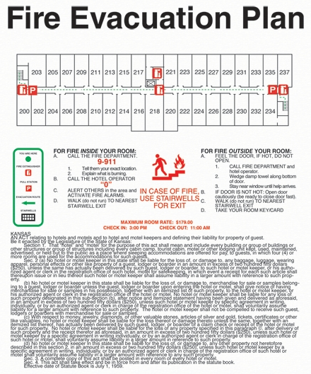

Part 7
Emergency Procedures for Supervisory Staff/Front Desk

Upon Discovery of Fire

- Leave fire area immediately and close doors. Alert occupants.
- Sound Fire Alarm and follow the fire alarm supervisory procedures.
- Call 9-1-1 from a safe location.
- Exit the building via the nearest exit.
- Await the arrival of Fire Department at the main entrance.

Upon Hearing of a Fire Condition

- Ensure that the other occupants have been notified of the emergency conditions.
- Check Fire Alarm Annunciator/Panel to determine area of origin of alarm.
- Notify the Fire Department of the emergency condition. Dial 9-1-1. If it is safe to do so, supervise the evacuation of all occupants, including those requiring assistance.
- Upon the arrival of the Fire Department, inform the fire officer of the conditions in the building and co-ordinate the efforts of the Supervisory staff with those of the Fire Department.
- Provide access and vital information to the Firefighters as to location of persons, master keys for this occupancy and service rooms, etc.

Related Duties

In general:

- Keep the doors in fire separations closed at all times. This includes apartment doors and stairway separation doors.
- Keep EXITS and access to exits, inside and outside, clear of any obstructions at all times.
- Maintain sufficient lighting in exits and corridors.
- Do not permit combustible materials to accumulate in quantities or locations that would constitute a fire hazard. Keep stairways free of combustible storage and obstructions.
- Outdoor storage receptacles, such as dumpsters, used for combustible materials shall be located so that they do not create a fire hazard to buildings.
- Promptly remove all combustible waste from areas where waste is placed for disposal, if applicable.
- Keep access roadways, fire routes and fire department connections clear and accessible for fire department use.
- Hydrants shall be readily available and unobstructed for use at all times and shall be maintained free of snow and ice accumulations.
- Maintain the fire protection equipment in good operating condition at all times.
- Participate in fire drills. Occupants’ participation should be encouraged but not required.
- Have a working knowledge of the building fire and life safety systems.
- Ensure the building fire and life safety systems are in operating condition.
- Be available upon notification of a fire emergency to fulfil your obligation as described in this plan.
- Arrange for a substitute in your absence.
- Comply with the requirements of the Ontario Fire Code.
- In the event of any shutdown of fire and life safety systems, notify the Fire Department and initiate approved alternative measures.

Emergency Procedures
Additional Information/Comments

Part 8
Responsibilities of the Owner / Occupant

The building owner has numerous responsibilities related to fire safety and must ensure that the following measures are enacted:

- Establishment of emergency procedures to be followed at the time of an emergency.
- Post and maintain at least one (1) copy of the fire emergency procedures on each floor level.
- A copy of the emergency procedures, location of exits and the fire safety rules shall be posted on the inside of the egress doors of each guest suite.
- Appointment and organization of designated supervisory staff to carry out safety duties. In hotel establishments, there shall be sufficient supervisory staff available to carry out the duties as required in the fire safety plan, and in buildings greater than three storeys in building height or having a total area greater than 4000 m², supervisory staff shall be on duty whenever the building is occupied.
- Instruction of supervisory staff and other occupants so that they are aware of their responsibilities for fire safety. Ensure you, or your supervisory staff, are available upon notification of a fire emergency to fulfil your obligation as described in the Fire Safety Plan.
- Designate and train sufficient alternates to replace supervisory staff during any absence.
- Employees in a hotel establishment shall be instructed on the procedures outlined in the fire safety
plan, and the use of firefighting equipment, including portable fire extinguishers and, where
applicable, standpipe and hose systems.
- Holding of fire drills in accordance with the Fire Code, incorporating Emergency Procedures appropriate to the building. Every employee in a hotel establishment shall take part in at least one fire drill during each 12-month period.
- Control of fire hazards in the building.
- Maintenance of building facilities provided for safety of the occupants. Where testing is required for compliance with this Code, the tests shall be carried out by the owner or the owner's agent.
- Provisions of alternate measures for safety of occupants during shut down of fire protection equipment.
- Ensure that checks, tests and inspections as required by the Ontario Fire Code are completed on schedule, and that the original or a copy of these records are retained at the building premises for examination by the Chief Fire Official for a minimum period of two (2) years.
- Ensure the continuation of the monitoring of the fire alarm system when building required to transmit a signal to the fire department and that the central station operator is Fire Code compliant.
- Ensure the initial verification of test reports for fire protection systems installed after November 21, 2007, are retained throughout the life of the systems.
- Keep a copy of the approved Fire Safety Plan on the premises in an approved location. Ensure one copy of the approved fire safety plan is kept posted in the main reception area of the hotel/motel.
- Notification of the Chief Fire Official regarding changes in the Fire Safety Plan.
- Review Fire Safety Plan as often as necessary, but at intervals not greater than 12 months to ensure that it takes account of changes in the use and other characteristics of the building.

Part 9

Fire Hazards

A high standard of housekeeping and building maintenance is probably the most important single factor in the prevention of fire. Listed below are some specific hazards.

To avoid fire hazards in the building, owner/staff must:

- Avoid all opportunities for careless smoking.
- Never leave anything that may burn or cause a trip hazard in the halls, corridors and/or stairways. Corridors serving as access to exits for guest suites may contain solid wood or other approved furniture, provided the furniture does not create an obstruction to the egress route.
- Ensure fire and smoke barrier doors are operating properly and not wedged open.
- Ensure waste containers in public washrooms and in other public areas in a hotel are constructed of non-combustible materials and have self-closing covers, or be approved by the Chief Fire Official.
- Ensure clothes dryers are properly vented.
- Always clean out clothes dryer lint collector before and after use.
- Not use unsafe electrical appliances, frayed extension cords, over-loaded outlets or lamp wire for permanent wiring. Never allow the use of extension cords as permanent wiring.
- Never allow combustible material to be stored in non-approved areas.
- Ensure the proper storage of flammable liquids and gases.
- Properly clean kitchen hoods and filters to ensure system is not grease laden.
- Properly dispose of oily rags.

In general, owner/staff should:

- Know how to alarm occupants of building, know where exits are located.
- Call Fire Department immediately (9-1-1) whenever you need assistance.
- Know the correct address of the building.
- Notify the building owner/property management if special assistance if required in the event of an emergency.
- Know the fire alarm signals and the procedures established to implement safe evacuation. Read and follow the manufacturers smoke alarm (and CO detector if applicable) instructions, available from building owner/property management.
- Know the supervisory staff in your building.
- Report any fire hazard to supervisory staff.
- Know the stairwell designation and the crossover floors (if any).

Part 10
Fire Extinguishment, Control or Confinement

Most fires start small. Except for explosions, fires can usually be brought under control if they are attacked correctly with the right type and size of extinguisher within the first two minutes. In the event a small fire cannot be extinguished with the use of a portable fire extinguisher, or smoke presents a hazard for the operator, the door to the area should be closed to confine and contain the fire. If fighting the fire, ensure that the Fire Alarm System has been activated and the Brockville Fire Department has been notified prior to any attempt to extinguish the fire. Only those persons who are trained and familiar with extinguisher operation may attempt to fight the fire. Employees in a hotel establishment shall be instructed on the use of firefighting equipment, including portable fire extinguishers.

The decision to use a fire extinguisher is one that is made after considering the following:

• Type of fire (Class A, B, C, D or K)
• Type of fire extinguisher available for the fire
• Size and intensity of fire
• Size and capacity of the fire extinguisher
• Exit location and clear route away from fire

When not to fight a fire…

• If the fire could block your only exit
• If the fire is spreading quickly
• If the type or size of the extinguisher is wrong
• If the fire is too large
• If you don’t know how to use the fire extinguisher

Suggested Operation of Portable Fire Extinguishers

Remember the (PASS) acronym

P - Pull the safety pin
A - Aim the nozzle
S - Squeeze the trigger handle
S - Sweep from side to side (watch for fire restarting)

Never re-hang extinguishers after use. Ensure they are properly recharged by a person that is qualified to service portable fire extinguishers and that a replacement extinguisher is provided.

Keep extinguishers in a visible area without obstructions around them.

Part 11
Alternative Measures for Occupant Fire Safety

In the event of any shut-down of fire protection equipment systems or part thereof, in excess of 24 hours, the fire department shall be notified in writing. Occupants will be notified and instructions will be posted as to alternative provisions or actions to be taken in case of emergency. These provisions and actions must be acceptable to the Chief Fire Official.

All attempts to minimize the impact of malfunctioning equipment will be initiated. Where portions of a sprinkler or fire alarm system are placed out of service, service to remaining portions must be maintained, and where necessary, the use of watchmen, bull-horns, walkie-talkies, etc. will be employed to notify concerned parties of emergencies. Assistance and direction for specific situations will be sought from the Brockville Fire Department.

Procedures to be followed in the event of shutdown of any part of a fire protection system are as follows:

- Notify the Brockville Fire Department, dial (613) 498-1261 (DO NOT USE 9-1-1). Give your name, address and a description of the problem and when you expect it to be corrected. The Brockville Fire Department is to be notified in writing of shutdowns longer than 24 hours.

- Post notices at all exits and the main entrance, stating the problem and when it is expected to be corrected.

- Have staff of other reliable person(s) patrol the affected area(s) at least once every hour.

- Notify the Brockville Fire Department and the building occupants when repairs have been completed and systems are operational.

NOTE: All shutdowns will be confined to as limited an area and duration as possible. Cooking operations shall be suspended until the commercial cooking fixed extinguishing system is restored.

(See attached Fire Watch Duties and Report Log)

FIRE WATCH DUTIES

Definition: The term “fire watch” is used to describe a dedicated person or persons whose sole responsibility is to look for fires within an established area. Fire watch is required in the event of temporary failure of the fire alarm system or where activities require the interruption of any fire detection, suppression or alarm system component.
NOTE: All building occupants are to be notified in writing that the fire protection systems in the building are not functional and that a Fire Watch has been instituted until repairs have been made.

(1) At least one (1) qualified staff person shall be employed to complete fire watch duties of the unprotected building area whenever the building is occupied. Each person assigned to Fire Watch duties must be provided with the following equipment;

(i) Suitable means of communication (cell phone, portable radio, etc.) for notifying Fire Dept.
(ii) A portable air horn or other approved means of sounding an alarm
(iii) Flashlight
(iv) Clipboard and pen
(v) Copy of fire watch duties
(vi) Copy of the Fire Watch Log Sheet
(vii) Keys and/or access codes to provide entry to all rooms/spaces
(viii) Floor plan(s) of the building under Fire Watch

(2) Fire Watch personnel are to be familiar with the building and procedures for alerting the fire Department and all building occupants in the event of a fire.

(3) Rounds shall be diligently completed at least once each hour, and recorded immediately upon the conclusion of each round on the Fire Watch Log Sheet. The person completing the rounds will record the time each round was completed.

(4) Fire watch personnel are to have fire extinguishing equipment readily available and be trained in its use.

(5) If fire or smoke conditions are discovered, alert all building occupants by sounding a portable air horn or another device approved by the Chief Fire Official.

(6) A telephone must be readily available at all times to notify the Brockville Fire Department by calling 9-1-1. Always call from a safe area.

(7) Do not attempt to extinguish the fire unless it is safe to do so.

(8) Once building evacuation is completed, await emergency response personnel at a safe location and direct them to the scene. Do not re-enter the building without permission from the Fire Department.

(9) “Hot Works” such as welding or cutting shall be prohibited in the area where the sprinkler protection is impaired or be limited to areas where approved precautions have been put into place.

(10) While the sprinkler and/or fire alarm system(s) are shut down, assigned fire watch personnel shall patrol the area until both the fire alarm system and the sprinkler system has been restored.

(11) Exit doors, access to exits and corridors are to be checked periodically for proper operation and obstructions while performing Fire Watch duties.
FIRE WATCH LOG REPORT

___________________________ System out of service | Date:______________ | Time: ________
System Out of Service-Notification to Fire Department | Date:______________ | Time: ________

__________________________ System Back in Service | Date:______________ | Time: ________
System Back in Service-Notification to Fire Department | Date:______________ | Time: ________

PERSONS ASSIGNED TO FIRE WATCH DUTIES SHALL FOLLOW THE REQUIRMENTS LISTED ON THE FIRE WATCH DUTIES SHEET AND SHALL PATROL ALL UNPROTECTED AREAS OF THE BUILDING EVERY HOUR TO CHECK FOR SIGNS OF FIRE OR SMOKE CONDITIONS. ALL PATROLS ARE TO BE RECORDED ON THIS LOG REPORT IMMEDIATELY FOLLOWING EACH ROUND. RECORDS OF FIRE WATCH SHALL BE KEPT FOR 2 YEARS AFTER THEY ARE MADE, AND SHALL BE MADE AVAILABLE UPON REQUEST TO THE CHIEF FIRE OFFICIAL.

Fire Watch Duties Conducted By: ____________________________________________________
(PRINT NAME & POSITION)

Rounds | Start Time | Finished | Signature | Comments
1
2
3
4
5
6
7
8
9
10
11
12
13
14
15
16
17
18
19
20
21
22
23
24
Fire Watch Commenced: Date: __________________ Time: ___________

Start a new Fire Watch Log Report Sheet for each new day of fire watch.
Part 12

Fire Drills

Fire drills will be held at least once every 12 months for this hotel to ensure efficient execution of the Emergency Procedures by supervisory staff. In addition to this requirement, every employee in a hotel establishment shall take part in at least one fire drill during each 12-month period. Fire drill records are required to be retained for a period of 12 months after the fire drill and made available to the Chief Fire Official upon request.

The Fire Code (2.8.3.1.(1) of Div. B) states that the procedure for conducting fire drills shall be included in the fire safety plan, taking into consideration
(a) the building occupancy and its fire hazards,
(b) the safety features provided in the building ,
(c) the desirable degree of participation of occupants other than supervisory staff ,
(d) the number and degree of experience of participating supervisory staff , and
(e) the testing and operation of the emergency systems installed in buildings within the scope of Subsection 3.2.6. of Division B of the Building Code .

The fire drill procedures shall be prepared in consultation with the Chief Fire Official.

THE PROCEDURE IS AS FOLLOWS:

1) Notify all occupants 24 hours in advance of the approximate time when the drill is to take place and include the date of the drill.

2) Post signs containing the above information in the lobby and other locations where guests are most likely to see them.

3) Notify the Fire Department and monitoring agency (if alarm is monitored) before the fire alarm is activated.
FIRE DEPARTMENT PHONE NUMBER: (613) 498-1261 (NOT 911 FOR THIS PURPOSE)

4) Commence drill.

5) Reset alarm system and verify with the alarm company that alarm is reset.

6) Notify the Fire Department when drill has been completed if the alarm was activated.

7) Post-drill de-briefing meeting(s) will be held after drill to assess:
a) any problems that may have occurred
b) that all required fire protection equipment functioned as designed

8) Complete the appropriate fire drill document (as shown in fire safety plan) and retain the record for at least 12 months after the drill.

FIRE DRILL RECORD

Date: |  | Time: |  | Full Drill or Table-top exercise:
Device Activated:

On-Duty Manager/Supervisor Conducting Drill:

Staff Present:

Deficiencies Noted:

General Comments:
Part 13
Requirements of the Ontario Fire Code

Check/Test/Inspect requirements of the Ontario Fire Code:

To assist you in fulfilling your obligations, included is a list of the portions of the Fire Code that requires checks, inspections and/or tests to be conducted of the facilities. It is suggested that you read over this list and perform or have performed the necessary checks, inspections and/or tests for the items which may apply to your property.

This list has been prepared for purposes of convenience only. For accurate reference, the Fire Code shall be consulted. Where specific references to checking, inspection and testing of fire safety devices are not made in this Code, such devices shall be maintained to ensure they operate as per their design requirements.

Where a building or its contents must be tested for compliance with this Code, the tests shall be carried out by the owner or the owner's agent within such reasonable time as the Chief Fire Official may determine.

Any appliance, device or component of a device that does not operate or appear to operate as intended when checked, inspected or tested as required by this Code shall be repaired or replaced if the failure or malfunctioning of the appliance, device or component would adversely affect fire or life safety.

Fire Prevention Officers may check to ensure that the necessary checks, inspections and/or tests are being done, when conducting their inspections, and asked to see the required written records.

Definitions for key words are as follows:

Check means visual observation to ensure the device or system is in place and is not obviously damaged or obstructed

Test means the operation of a device or system to ensure that it will perform in accordance with its intended operation or function

Inspect means physical examination to determine that the device or system will apparently perform in accordance with its intended function

It is stated in the Fire Code that written records of all tests and corrective measures are required to be retained for a period of two years after they are made, and shall be available upon request to the Chief Fire Official. Records shall be made and the original or a copy shall be retained at the building premises for examination by the Chief Fire Official. Records of tests and corrective measures or operational procedures shall be retained so that at least the current and the immediately preceding reports are available, however; records shall be retained for a period of at least two years after being prepared.

NOTE: The initial verification or test reports for fire protection systems installed after November 21, 2007 shall be retained on the premises throughout the life of the systems. This requirement applies to systems installed in accordance with this Code or the Building Code.
General Fire Protection Systems/Equipment

General Responsibility
(example: Owner, Superintendent, Contractor)
Doors in fire separations shall be checked as frequently as necessary to ensure that they remain closed.
Exit signs shall be clearly visible and maintained in a clean and legible condition.
Internally illuminated exit signs shall be kept clearly illuminated at all times, when the building is occupied.

Weekly

When subject to accumulation of combustible deposits, hoods, filters and ducts shall be checked weekly and be cleaned when such deposits create an undue fire hazard.

Monthly

Doors in fire separations shall be inspected monthly for proper operation.

Yearly

Fire dampers and fire-stop flaps shall be inspected annually, or based on a schedule via contractor acceptable to the Chief Fire Official.
Every chimney, flue and flue pipe shall be inspected annually and cleaned as often as necessary to keep them free from ccumulations of combustible deposits.
Disconnect switches for mechanical air-conditioning and ventilating systems shall be inspected annually to establish that the system can be shut down.
Spark arresters shall be cleaned annually or more frequently where accumulations of debris will adversely affect operations. Burnt-out arresters shall be repaired or replaced.

Portable Fire Extinguishers
General Responsibility

Each portable extinguisher shall have a tag securely attached to it showing the maintenance or recharge date, the servicing agency and the signature of the person who performed the service.
A permanent record containing the maintenance date, the examiner’s name and a description of any work or hydrostatic testing carried out shall be prepared and maintained for each portable extinguisher.
All extinguishers shall be recharged after use or as indicated by an inspection or when performing maintenance. When recharging is performed, the recommendations of the manufacturer shall be followed.

Monthly Responsibility

Portable extinguishers shall be inspected monthly.

Yearly

Extinguishers shall be subject to maintenance not more than one year apart or when specifically indicated by an inspection.
Maintenance procedures shall include a thorough examination of the three basic elements of an extinguisher: a) mechanical parts b) extinguishing agent c) expelling means
Every twelve months, pump tank water, and pump tank calcium chloride base antifreeze types of extinguishers shall be recharged with new chemicals or water, as applicable

5 Years

Every five years, pressurized water and carbon dioxide fire extinguishers shall be hydrostatically tested.

6 Years

Every six years, stored pressure extinguishers that require a 12 year hydrostatic test shall be emptied and subjected to the applicable maintenance procedures.

Fire Alarm System
General Responsibility

Fire alarm and voice communication system components shall be kept unobstructed.
Fire alarm shall be kept unobstructed.
Fire alarm system power supply disconnect switches shall be locked on in an approved manner.

Daily Responsibility

The following daily checks shall be conducted if a fault is established, appropriate corrective action shall be taken.
a) Check the principle and remote trouble lights for trouble indication;
b) Inspection of the AC power-on light shall be done to ensure its normal operation.

Monthly

Every month the following tests shall be conducted under battery back up power and if a fault is established, appropriate corrective action shall be taken:
a) one manual fire alarm initiating device shall be operated, on a rotating basis, and shall initiate an alarm condition
b) function of all signal devices shall be ensured
c) the annunciator panel shall be checked to ensure correct annunciation
d) intended function of the audible and visual trouble signals shall be ensured
e) fire alarm batteries shall be checked to ensure that:
i) terminals are clean and lubricated where necessary;
ii) terminal clamps are clean and tight;
- electrolyte level and specific gravity, where applicable, meet manufacturer’s specifications
Voice paging capability to one zone shall be tested monthly on a rotational basis.
One emergency telephone shall be tested monthly on a rotational basis for operation and correct indication at control unit.
Loudspeakers shall be tested monthly as an all-call signal to ensure they function as intended.
At least one firefighter’s emergency telephone shall be tested monthly on a rotational basis to ensure communication with the control unit. All telephones shall be tested each year.

Yearly Responsibility

Yearly tests conducted by a certified alarm contractor as required by Section 1.2.1.2. of Division C of the Ontario Fire Code, 2007. Tests shall be in conformance with CAN/ULC S536, “Inspection and Testing of Fire Alarm Systems”.
Voice communications between floor areas and the central alarm control facility shall be tested annually, as required for fire alarm initiating and signally devices.

Inter-connected Smoke Alarms
Weekly (As Required By Code)

The power supply shall be checked weekly.

Monthly

The operability of the interconnected system shall be confirmed monthly, by testing at least one smoke alarm using its test function, on a rotational basis.

Yearly

Where installed, each manual pull station shall be tested to ensure activation of the interconnected smoke alarms on an annual basis.
Interconnected smoke alarms shall be tested and maintained in operating condition in conformance with CAN/ULC – S552, Standard for the Maintenance & Testing of Smoke Alarms & as required by the Fire Code.

Smoke Alarms
General Responsibility

Ensure all suite smoke alarms are maintained in operating condition.

Standpipe Systems
Monthly Responsibility

Hose cabinets shall be inspected monthly to ensure that the hose and equipment are in the proper position and appear to be operable.

Yearly

Plugs or caps on Fire Department connections shall be removed annually and the threads inspected for wear, rust or obstruction. Re-secure plugs or caps, wrench tight.
If plugs or caps are missing, examine the Fire Department connections for obstructions, back flush if necessary, and replace plugs or caps.
Hose valves shall be inspected annually to ensure that they are tight and that there is no water leakage into the hose.
Standpipe hose shall be removed and re-racked annually and after use. Any worn gaskets in the couplings, at the hose valve and at the nozzle shall be replaced.
Flow and Pressure tests shall be conducted annually at the highest and most remote hose valve or hose connection to verify that the water supply for the standpipe system is provided as originally designed (Hotels only)

Sprinkler Systems (Wet)
General Responsibility

Auxiliary drains shall be inspected as required to prevent freezing.
Fire Dept. connections shall be equipped with plugs or caps that are secured wrench-tight

Weekly

Except for electrically supervised valves, all valves controlling water supplies to sprinklers and alarm connections shall be checked weekly to ensure that they are sealed or locked in the open position.
Water supply pressure and system air or water pressure shall be checked weekly by using gauges to ensure that the system is maintained at the required operating pressure.

Monthly Responsibility

On all sprinkler systems, an alarm test, using the alarm test connection located at the sprinkler valve, shall be performed monthly.

Two Months Responsibility

All transmitters and water flow devices shall be tested at two month intervals.

Six Months

Gate-valve supervisory switches and other sprinkler system supervisory devices shall be tested at six month intervals.

Yearly

Exposed sprinkler piping hangers shall be checked yearly to ensure that they are kept in good repair.
Sprinkler heads shall be checked at least once per year to ensure that they are kept in good repair.
Sprinkler heads shall be checked at least once per year to ensure that they are free from damage, corrosion, grease, dust, paint, or whitewash. They shall be replaced where necessary as a result of such conditions.
On wet sprinkler systems, water-flow alarm test using the most hydraulically remote test connection, shall be performed annually.
Sprinkler system water pressure shall be tested annually or after any sprinkler system control valve has been operated, with the main drain valve fully open, to ensure that there are no obstructions or deterioration of the main water supply.
Plugs or caps on Fire Department connections shall be removed annually and the threads inspected of wear, rust or obstruction. Re-secure plugs or caps, wrench tight. If plugs or caps are missing, examine the Fire Department connection for obstructions, back flush if necessary and replace plugs or caps.

Sprinkler Systems (Dry)
General Responsibility

Auxiliary drains shall be inspected as required to prevent freezing.
Dry-pipe valve rooms or enclosures in unheated buildings shall be checked as often as necessary when the outside temperature falls below 0º Celsius to ensure that the system does not freeze.

Weekly Responsibility

Except for electrically supervised valves, all valves controlling water supplies to sprinklers and alarm connections shall be checked weekly to ensure that they are sealed or locked in the open position.
Water supply pressure and system air or water pressure shall be checked weekly by using gauges to ensure that the system is maintained at the required operating pressure.
System pressure gauges shall be checked weekly. The system shall be maintained at the required operating pressure.

Monthly

On all sprinkler systems, an alarm test, using the alarm test connection located at the sprinkler valve, shall be performed monthly.

2 Months Responsibility
All transmitters and water flow devices shall be tested at two month intervals.

3 Months

The priming water supply for dry pipe systems shall be inspected every three months to ensure that the proper level above the dry pipe valve is maintained.

6 Months

Gate-valve supervisory switches and other sprinkler system supervisory devices shall be tested at six month intervals.

Yearly Responsibility

Exposed sprinkler piping hangers shall be checked yearly to ensure that they are kept in good repair.
Sprinkler heads shall be checked at least once per year to ensure that they are free from damage, corrosion, grease dust, paint, or whitewash. They shall be replaced where necessary as a result of such conditions.

Yearly Sprinkler Systems (Dry) (cont’d) Responsibility

Sprinkler system water pressure shall be tested annually or after any sprinkler system control valve has been operated, with the main drain valve fully open, to ensure that there are no obstructions or deterioration of the main water supply.
Plugs or caps on Fire Department connections shall be removed annually and the threads inspected for wear, rust or obstruction. Re-secure plugs or caps wrench tight. If plugs or caps are missing, examine the Fire Department connection for obstructions, back flush if necessary and replace plugs or caps.
Dry pipe valves shall be tripped annually by means of the system test pipe, to ensure that they operate satisfactorily and that the sprinkler alarms are in operating condition. A full flow trip test, with the control valve fully open, shall be conducted at least every three years.

15 Years Responsibility

Every fifteen years, dry pipe systems shall be inspected for obstructions in the sprinkler piping and if necessary, the entire system shall be flushed of foreign material.

Water Supplies for Firefighting (Fire Pumps)
Daily Responsibility

The temperature of pump rooms shall be checked daily during freezing weather.

Monthly (Hotels Only)

Valves controlling water supplies exclusively for fire protection systems shall be inspected weekly to ensure that they are fully open and sealed or locked in that position.
Fire pumps shall be started once per month at rated speed. The fire pump discharge pressure, suction pressure, lubricating oil level, operative condition of relief valves, priming water level and general operating conditions shall be inspected.
Internal combustion engine fire pumps shall be operated once per month for a sufficient time to bring the engine up to normal operating temperature. The storage batteries, lubrication systems and fuel supplies shall be inspected once a month.

Yearly

Fire pumps shall be tested annually at full rated capacity to ensure that they are capable of delivering the rated flow.

Private Fire Hydrants
General Responsibility

Hydrants shall be readily available and unobstructed for use at all times.

Yearly

Hydrants shall be inspected annually after each use.
Ensure hydrants are equipped with port caps secured wrench tight. The port caps shall be removed annually and inspected for wear, rust or obstructions.
The hydrant barrel shall be inspected annually to ensure that no water has accumulated.
The drain valve shall be inspected for operation if water is found in the hydrant barrel when main valve is closed.
Hydrant waterflow shall be inspected annually and a record shall be kept.

Water Supplies for Firefighting (Water Tanks)
Daily Responsibility

Water tank heat equipment, tank enclosure and/or water temperature shall be checked daily during freezing weather.

Weekly

Water levels and air pressure in pressure tanks shall be checked weekly and the relief valves on the air and the water lines shall be inspected weekly.

Monthly

Water level in gravity tanks shall be inspected monthly.

Yearly

An annual inspection shall be made of water tanks for fire protection, tank supporting structures and water supply systems including piping, control valves, check valves, heating systems, mercury gauges and expansion joints to ensure that they are in operating condition.
Cathodic protection equipment in water tanks shall be inspected annually.

2 Years Responsibility

Water tanks shall be checked every two years for corrosion.

5 Years

Water tanks shall be inspected every five years and scraped and repainted as required.

Smoke Shafts and Venting Equipment
General Responsibility

Access to windows and panels required for venting floor areas and vents to vestibules permitted to be manually openable shall be kept free of obstructions, openable without keys and operable at times.

6 Months

All elevators in an elevator shaft, that is intended for use as a smoke shaft, be inspected semi-annually to ensure that on activation of the fire alarm system, the elevators will return to the street floor and remain inoperative.

Yearly

A closure in an opening to the outdoors at the top of a smoke shaft, shall be inspected annually to ensure that it will open:
a) manually, outside from the building
b) on a signal from the smoke/heat actuated device in the smoke shaft, and;
c) when a closure in an opening between a floor area and the smoke shaft opens
Controls for air-handling systems for venting in the event of a fire, shall be inspected annually to ensure that air is exhausted from each floor area to the outdoors.

5 Years

Closures in vent openings into smoke shafts from each floor shall be inspected sequentially over a period not to exceed 5 years.

Smoke Control Measures
General Responsibility

Where smoke control measures contained in the supplement to the National Building Code of Canada 1995, Chapter 3, “Measures for Fire Safety in High Buildings” are used, the inspections and tests shall be as outlined in Section 7.3 of the National Fire Code of Canada.
Where a smoke control system is designed to meet the requirements of The Ontario Building Code, the inspections and tests shall be in accordance with procedures established by the designer of the system.

Commercial Cooking Equipment
General Responsibility

Commercial cooking equipment exhaust and fire protection systems shall be installed and maintained in conformance with NFPA 96, “Ventilation Control and Fire
Protection of Commercial Cooking Operations”.
Ensure wet chemical or alkali based dry chemical portable fire extinguishers are provided to protect commercial cooking equipment and are readily available for use in an emergency.

Weekly

Hoods, grease removal devices, fans, ducts, and other equipment shall be checked weekly and cleaned at frequent intervals, prior to surfaces becoming heavily contaminated with grease or oily sludge.

6 Months

Inspection and servicing of the fire extinguishing system shall be made at least every six months by properly trained and qualified persons in conformance with Ontario Fire Code, Section 6.8.1.1.

Emergency Lighting System
Daily Responsibility

Check pilot lights for indication of proper operation.

Monthly

Batteries shall be inspected monthly and maintained as per manufacturer’s specifications.
Ensure that battery surface is clean and dry.
Ensure that terminal connections are clean, free of corrosion and lubricated.
Ensure that the terminal clamps are clean and tight as per manufacturer’s specifications.
Emergency lighting equipment shall be tested monthly to ensure that the emergency lighting will function upon failure of the primary power supply.

Yearly

Emergency lighting equipment shall be tested annually to ensure that the units will provide emergency lighting for a duration equal to the design criteria under simulated power failure conditions.
After completion, the charging conditions for voltage and current and the recovery period will be tested annually to ensure that he charging system is in accordance with the manufacturer’s specifications.

Elevators (High Buildings)
General Responsibility

Ensure keys required to recall elevators and to permit independent operations are in their approved location.
Maintain correct signage for firefighters’ elevator.

3 Months

Every three months the elevator door opening devices operated by means of photo-electric cells shall be tested to ensure that the devices become inoperative after the door has been held open for more than 20 seconds with the photo-electric cell covered.
The key operated switch located outside an elevator shaft shall be tested to ensure that the actuation of the switch will render the emergency stop button in each car inoperative and bring all cars to the street floor or transfer lobby by cancelling all other calls after the car has stopped at the next floor at which it can make a normal stop.
Key operated switches in each elevator car shall be tested to ensure that the actuation of the switch will:
a) enable the elevators to be operable independently of other elevators
b) allow operation of the elevator without interference from floor call buttons
c) render door re-opening devices inoperative
d) control the opening of power operated doors only by the continuous pressure on the “door open” button to ensure that if the button is released while the door is opening, the doors will automatically close

Emergency Power Systems
General Responsibility

Emergency power systems shall be inspected, tested and maintained in conformance with CSA C282, “Emergency Electrical Power Supply for Buildings”.
To ensure continued reliable operation, the emergency power supply equipment shall be operated and maintained in accordance with manufacturer’s instructions.
At least two copies of the instruction manual shall be maintained.

Monthly Responsibility

The emergency electrical power shall be completely tested monthly as follows:

a) Simulate a failure of the normal power supply.
b) Arrange so that:
i) an engine generator set operates under at least 30% of the rated load for 60 minutes and;
ii) all automatic transfer switches are operated under load.
c) Include an inspection for correct function of all auxiliary equipment such as radiator shutter control, coolant pumps, fuel transfer pumps, oil coolers and engine room ventilation controls.
d) Record all instrument readings associated with the prime mover and generator and a verification that they are normal.
e) Log and report as further prescribed in the manual of instruction for operation and maintenance.
Check fuel supply for sufficient quantity.

Annually

Test the generator, control panel, and transfer switch in conformance with CSA C282, “Emergency Electrical Power Supply for Buildings”.

Maintenance
Additional Comments

Part 14
Fire Safety Plan Review Record

The Fire Safety Plan must be reviewed as often as necessary, but at intervals not greater than 12 months to ensure that it takes account of changes in the use and other characteristics of the building. It is the responsibility of the owner to ensure that the information contained within the Fire Safety Plan is accurate and complete. (Ontario Fire Code 2.8.2.1.(4) of Division B).
--------------------------------------------------------------------------------------------------------------------------

Date of Review: ____________________ Reviewed By: ______________________________

Owner/Position: ____________________ Signature: _________________________________

--------------------------------------------------------------------------------------------------------------------------

Date of Review: ____________________ Reviewed By: ______________________________

Owner/Position: ____________________ Signature: _________________________________

--------------------------------------------------------------------------------------------------------------------------

Date of Review: ____________________ Reviewed By: ______________________________

Owner/Position: ____________________ Signature: _________________________________

--------------------------------------------------------------------------------------------------------------------------

Date of Review: ____________________ Reviewed By: ______________________________

Owner/Position: ____________________ Signature: _________________________________

--------------------------------------------------------------------------------------------------------------------------

Date of Review: ____________________ Reviewed By: ______________________________

Owner/Position: ____________________ Signature: _________________________________

--------------------------------------------------------------------------------------------------------------------------
Date of Review: ____________________ Reviewed By: ______________________________

Owner/Position: ____________________ Signature: _________________________________

--------------------------------------------------------------------------------------------------------------------------

Date of Review: ____________________ Reviewed By: ______________________________

Owner/Position: ____________________ Signature: _________________________________

--------------------------------------------------------------------------------------------------------------------------

